Productivity Prediction of Garment Employees
Sabun Dhital
DSCI ECON 521
May 3rd, 2026

Submitted to
Dr. Mike Allgrunn
University of South Dakota

Introduction
The garment industry is one of the major components of industrialization in today’s world. By 2024, the global apparel market was expected to be worth $1.77 trillion. The garment industry employs approximately 75 million people worldwide, and in countries like Bangladesh, India, and China, it is one of the major contributor for economic growth. Despite its macroeconomic importance, the microeconomic factors for employee-level productivity within garment factories is not properly studied. It is a highly labor-intensive industry, which requires a lot of manual processes, and fulfilling demand depends on the production and productivity of garment employees. This study uses ordinary least squares (OLS) regression to examine the determinants of worker productivity using daily team-level observations based on Bangladeshi garment factory.
The objective of the project is to determine the key factors that influence actual productivity in the garment industry. The analysis makes use of several explanatory variables, such as department, day, smv (Standard Minute Value), overtime, incentives, idle time, idle workers, number of style changes, number of workers, and targeted productivity. In this study, actual productivity is used as the dependent variable, while the other variables are used as independent variables to explain variations in actual productivity.

Data and methodology
The data used in this study comes from the UC Irvine Machine Learning Repository, specifically the Productivity Prediction of Garment Employees dataset, which covers the period from January 1, 2015, to November 3, 2015. The UC Irvine Machine Learning Repository is one of the most widely used public databases for machine learning and data analysis research. This dataset was originally collected from a garment manufacturing factory in Bangladesh and has been made publicly available for research purposes.

2.1 Variable Description
The dataset contains 15 variables and 1,197 observations, which are as follows:
Variable | Type | Description
date | Categorical | Records date of observation
week | Categorical | Captures within month productivity cycles week 1 to week 5 (renamed to week from quarter)
department | Categorical | Refers to associated department within garment industry
day | Categorical | Day of the week (Mon, Tue, Wed, Thu, Sat)
Team | Categorical | Represents associated team member within the department from 1-12
smv | Continuous | Standard Minute Value allocated for specific task
wip | Continuous | Work in Progress unfinished work in queue
Over_time | Continuous | Overtime in minutes worked by each team in minutes
incentive | Continuous | Incentive provided to workers in Bangladeshi Taka
idle_time | Continuous | Minutes lost due to production disruptions
idle_men | Continuous | Number of workers idled during the shift
no_of_style_change | Count (0–2) | Number of style changes of a particular product
no_of_workers | Continuous | Total workers in the team on the given day
targeted_productivity | Continuous | Targeted productivity set by the authority for each team for each day.
actual_productivity | Continuous | The actual % of productivity that was delivered by the workers.
Table 3: Variable name, type and description

2.2. Missing variables
An examination of the dataset showed that there are missing values in work in progress (wip) which records 506 missing values out of 1,197 observations. As such, the variable wip is dropped from our analysis because other chosen variables already capture key factors affecting actual productivity. Further analysis into the dataset revealed that all missing wip values correspond exclusively to the finishing department, suggesting the variable may not be applicable in that department.

2.3 Data Cleaning and Preparation
For data cleaning and preparation first, extra spaces in the department variable were removed so that categories such as “finishing” and “sewing” were recorded consistently. The variable quarter is relabeled as a week to better reflect the actual time periods (weeks of the month from 1 to 5) it represents and improves interpretability in the analysis. Similarly, the categorical variables week, department, day were converted into dummy variables so they could be included in the regression model. Additionally, the incentive is converted from Bangladeshi Taka to USD, using the 2015 conversion rate. Similarly, we will be proceeding with variables that have more explanatory power to regression analysis.

2.3 Summary Statistics
Variable | Obs | Mean | Std. Dev. | Min | Max
actual_production | 1,197 | 0.7350911 | 0.1744879 | 0.2337055 | 1.120438
targeted_productivity | 1,197 | 0.7296324 | 0.0978910 | 0.07 | 0.8
smv | 1,197 | 15.06217 | 10.94322 | 2.9 | 54.56
over_time | 1,197 | 4567.46 | 3348.824 | 0 | 25920
incentive | 1,197 | 38.21053 | 160.1826 | 0 | 3600
idle_time | 1,197 | 0.7301587 | 12.70976 | 0 | 300
idle_men | 1,197 | 0.3692565 | 3.268987 | 0 | 45
no_of_style | 1,197 | 0.1503759 | 0.4278479 | 0 | 2
no_of_workers | 1,197 | 34.60986 | 22.19769 | 2 | 89
Table 2: summary statistics of actual production, targeted productivity, smv, over time incentive, idle time, idle men no of style no of workers
Department | Frequency | Percent | Cumulative Percent
Finishing | 506 | 42.27% | 42.27%
Sewing | 691 | 57.73% | 100.00%
Total | 1,197 | 100.00% | —
Table 3: Frequency distribution of department finishing and sewing
Day | Frequency | Percent | Cumulative Percent
Monday | 199 | 16.62% | 16.62%
Saturday | 187 | 15.62% | 32.25%
Sunday | 203 | 16.96% | 49.21%
Thursday | 199 | 16.62% | 65.83%
Tuesday | 201 | 16.79% | 82.62%
Wednesday | 208 | 17.38% | 100.00%
Total | 1,197 | 100.00% | —
Table 4: Frequency distribution of days in a week
Quarter | Frequency | Percent | Cumulative Percent
Week1 | 360 | 30.08% | 30.08%
Week2 | 335 | 27.99% | 58.06%
Week3 | 210 | 17.54% | 75.61%
Week4 | 248 | 20.72% | 96.32%
Week5 | 44 | 3.68% | 100.00%
Total | 1,197 | 100.00% | —
Table 5: Frequency distribution of weeks

Descriptive analysis
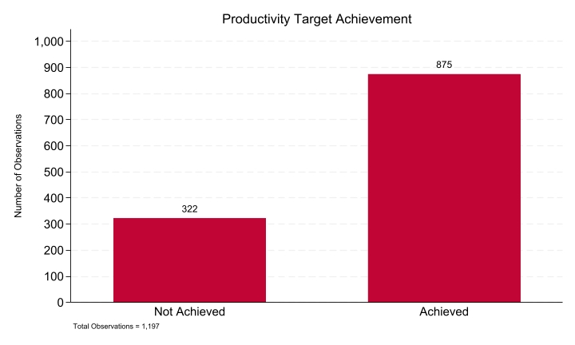
Fig 1: Productivity target achievement achieved Vs not achieved
The productivity target achievement analysis shows a clear difference between achieved and non-achieved targets. Out of a total of 1,197 observations, 875 targets were successfully achieved, while 322 targets were not achieved. This indicates that the majority of targets were met, demonstrating a strong overall performance.
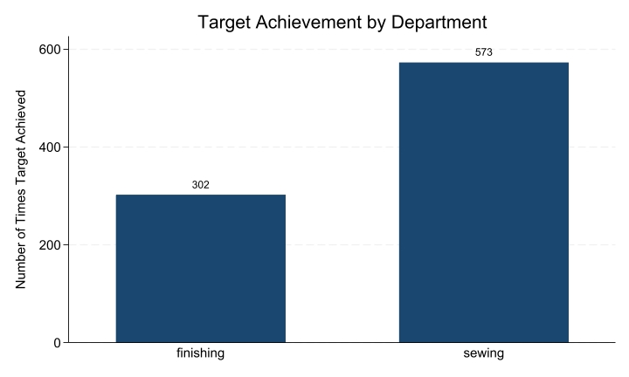
Fig 2: Target achievement by department sewing and finishing
The analysis of target achievement by department highlights a notable difference between the finishing and sewing departments. The sewing department achieved 573 targets, while the finishing department achieved 302 targets. This indicates that the sewing department significantly outperformed the finishing department in meeting productivity targets.
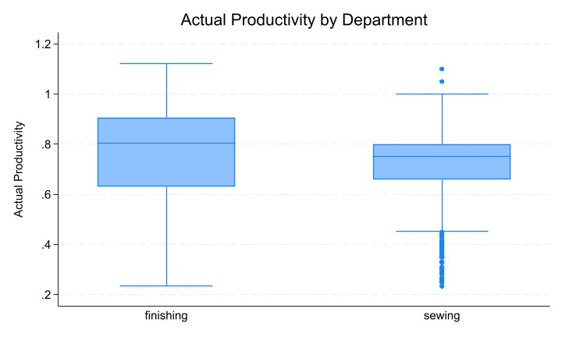
Fig 3: Box plot showcasing productivity by department
Figure 3 shows the box plot of actual productivity across the sewing and finishing department. The finishing department has the median productivity around 0.78, indicating consistent performance across shifts. The whiskers range from about 0.23 to 1.10, with no visible outliers, which indicates there are no extreme values of productivity in the finishing department. The sewing department has a median of 0.72 and wider Inter Quartile Range which indicates more variability in a day-to-day productivity. There is also presence of outliers clustered at 0.23 represnting siginificnatly lower productivity and above 1 shoring extreme productivity.
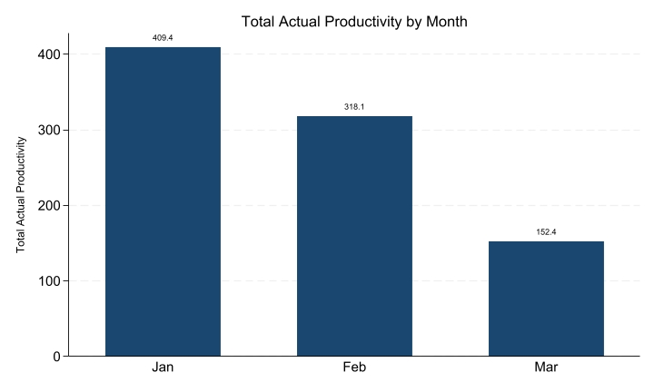
Fig 4: Actual productivity by month
The monthly productivity analysis indicates that January recorded the highest level of productivity, followed by February. In contrast, March showed the lowest productivity among the three months. This trend suggests a gradual decline in productivity over the observed period.
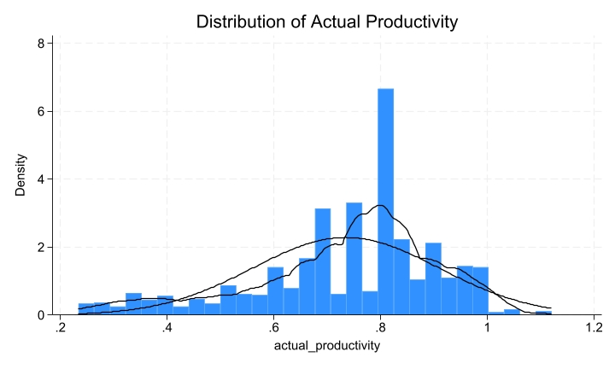
Fig 5: distribution of actual productivity
The distribution of actual productivity is left-skewed with a skewness value of −0.81, which shows that most garment workers tend to perform at higher productivity levels, concentrated around 0.75 to 0.85. The histogram shows that a few teams perform with lower productivity. Similarly, few teams exceed the productivity level above 1 which might have occurred due to few teams over achieving their production target.

Correlation Analysis
The correlation results show that targeted productivity has a moderate positive relationship with actual productivity, meaning higher targets are generally associated with higher output. Most other variables, such as SMV, overtime, incentive, idle time, and number of workers, have weak relationships with actual productivity. Idle time, idle men, and number of styles show negative relationships, indicating that more idle resources and higher product variation can reduce productivity slightly. Incentives have very little impact.
Additionally, some variables like SMV, overtime, and number of workers are highly correlated with each other. This suggests possible multicollinearity, which should be considered when building a regression model.

Correlation Analysis heatmap
Variable | actual_prod | targeted_prod | smv | over_time | incentive | idle_time | idle_men | no_of_style | no_of_workers
actual_prod | 1
targeted_prod | 0.4216 | 1
smv | -0.1221 | -0.0695 | 1
over_time | -0.0542 | -0.0886 | 0.6749 | 1
incentive | 0.0765 | 0.0328 | 0.0326 | -0.0048 | 1
idle_time | -0.0809 | -0.0562 | 0.0569 | 0.031 | -0.012 | 1
idle_men | -0.1817 | -0.0538 | 0.1059 | -0.0179 | -0.0211 | 0.5591 | 1
no_of_style_change | -0.2074 | -0.2093 | 0.3154 | 0.0598 | -0.0266 | -0.0116 | 0.1336 | 1
no_of_workers | -0.058 | -0.0843 | 0.9122 | 0.7342 | 0.0492 | 0.058 | 0.1069 | 0.3278 | 1
Table 6: Correlation analysis heatmap
- Linear Regression
In our regression model, we will use variables targeted productivity, smv, incentive, idle_time, idle_men, no_of_style_change, department (dummy variable), and days (dummy variable). Since our correlation analysis showed that smv, no of workers and overtime are highly correlated we will only keep smv and no of workers because it is theoretically significant. From an econometric standpoint, overtime was dropped from the model because it is potentially endogenous teams that fail to meet productivity targets are more likely to work overtime, creating a reverse causality problem that violates the OLS exogeneity assumption.

Statistic | Value
Number of Obs | 1,197
F-statistic | 55.46
Prob > F | 0.0000
R-squared | 0.2461
Adjusted R² | 0.2417
Root MSE | 0.1520
Table 7: Baseline model 1 summary
Variable | Coefficient | Std. Error | t-value | p-value | 95% Confidence Interval
Targeted Productivity | 0.7069 | 0.0460 | 15.36 | 0.000 | [0.6166, 0.7973]
SMV | -0.0065 | 0.00098 | -6.64 | 0.000 | [-0.0084, -0.0049]
Incentive (USD) | 0.0062 | 0.0030 | 2.05 | 0.041 | [0.0003, 0.0121]
Idle Time | 0.00044 | 0.00042 | 1.05 | 0.293 | [-0.0004, 0.0013]
Idle Men | -0.0087 | 0.0016 | -5.27 | 0.000 | [-0.0119, -0.0055]
No. of Style Change | -0.0413 | 0.0112 | -3.68 | 0.000 | [-0.0633, -0.0193]
No. of Workers | 0.0031 | 0.00049 | 6.37 | 0.000 | [0.0021, 0.0041]
Constant | 0.2171 | 0.0350 | 6.20 | 0.000 | [0.1484, 0.2857]
Table 8: Estimated Regression Coefficients, Standard Errors, and Statistical Significance for first model
The first model reports an R-squared of 0.24 and an adjusted R-squared of 0.24. Targeted productivity has a coefficient of 0.7069, meaning that a one-unit increase in targeted productivity increases actual productivity by 0.7069 units, ceteris paribus. It is the strongest predictor in the model and is statistically significant with a p-value of 0.000. Standard minute value (SMV) has a coefficient of −0.0065, indicating that an additional standard minute allocated reduces actual productivity by 0.0065 units, holding all other factors constant. Incentives have a coefficient of 0.0062, implying that a one-dollar increase in incentives is associated with a 0.006 increase in actual productivity, ceteris paribus. Although the magnitude is small, the effect is statistically significant with a p-value of 0.041. Idle time has a coefficient of 0.00044 and a p-value of 0.293, which is greater than the 5% significance level, making it statistically insignificant. Idle men have a coefficient of −0.0087, meaning that an additional idle worker reduces actual productivity by 0.0087 units, ceteris paribus. This effect is statistically significant with a p-value of 0.000.
The number of style changes has a coefficient of −0.0413, indicating that each additional style change is associated with a 0.0413 decrease in actual productivity, holding other factors constant. This effect is also statistically significant. Finally, the number of workers has a positive coefficient of 0.0031, suggesting that additional workers increase actual productivity by 0.003 units, ceteris paribus, and this result is statistically significant. However, the number of workers shows high correlation with SMV, which will be further examined using variance inflation factor (VIF) analysis in Model 2.

4.1 Multicollinearity check
Variable | VIF | 1/VIF
no_of_workers | 6.04 | 0.165466
smv | 5.98 | 0.167327
idle_men | 1.50 | 0.666502
idle_time | 1.48 | 0.677028
no_of_style | 1.20 | 0.836372
targeted_productivity | 1.05 | 0.951003
incentive_usd | 1.01 | 0.993426
Table 9: Variance Inflation Factor (VIF) Results
The Variance Inflation Factor (VIF) results confirm that multicollinearity is not a serious concern in Model 1. All VIF values are below the threshold of 10, with a mean VIF of 2.61 indicating that the regressors are not collinear with one another. The two highest values belong to no_of_workers (6.04) and smv (5.98), which reflect their relatively high correlation of 0.912 identified in the correlation analysis. However, these values are within acceptable bounds and do not compromise the reliability of the coefficient estimates.
Metric | Value
Number of Observations | 1,197
F(17, 1179) | 25.70
Prob > F | 0.0000
R-squared | 0.2704
Adjusted R-squared | 0.2598
Root MSE | 0.15012
Table 10: Regression model 2 summary
Variable | Coefficient | Std. Error | t-value | p-value | 95% Confidence Interval
Targeted Productivity | 0.7134 | 0.0457 | 15.61 | 0.000 | [0.6238, 0.8030]
SMV | -0.0062 | 0.0010 | -6.29 | 0.000 | [-0.0081, -0.0042]
Incentive (USD) | 0.0061 | 0.0031 | 1.99 | 0.047 | [0.0001, 0.0121]
Idle Time | 0.0004 | 0.0004 | 0.89 | 0.372 | [-0.0004, 0.0012]
Idle Men | -0.0085 | 0.0016 | -5.19 | 0.000 | [-0.0117, -0.0053]
No. of Style Change | -0.0356 | 0.0115 | -3.11 | 0.002 | [-0.0581, -0.0131]
No. of Workers | 0.0050 | 0.0007 | 7.29 | 0.000 | [0.0037, 0.0063]
Dept 2 | -0.0987 | 0.0258 | -3.82 | 0.000 | [-0.1494, -0.0480]
Week 2 | 0.0001 | 0.0116 | 0.01 | 0.995 | [-0.0227, 0.0229]
Week 3 | -0.0187 | 0.0133 | -1.41 | 0.158 | [-0.0448, 0.0073]
Week 4 | -0.0140 | 0.0129 | -1.09 | 0.275 | [-0.0393, 0.0112]
Week 5 | 0.0938 | 0.0250 | 3.76 | 0.000 | [0.0448, 0.1428]
Day 2 | 0.0083 | 0.0158 | 0.52 | 0.601 | [-0.0227, 0.0393]
Day 3 | -0.0034 | 0.0152 | -0.22 | 0.822 | [-0.0331, 0.0263]
Day 4 | -0.0087 | 0.0154 | -0.57 | 0.571 | [-0.0390, 0.0215]
Day 5 | 0.0178 | 0.0152 | 1.18 | 0.240 | [-0.0119, 0.0476]
Day 6 | 0.0037 | 0.0150 | 0.25 | 0.806 | [-0.0258, 0.0332]
Constant | 0.1971 | 0.0374 | 5.27 | 0.000 | [0.1237, 0.2704]
Table 11: Estimated Regression Coefficients, Standard Errors, and Statistical Significance for second regression model
The second regression model extends the baseline regression model by incorporating department, week, and day of the week dummy variables as structural controls. The R-squared increased from 0.2461 to 0.2704 while the adjusted R-squared rose from 0.2417 to 0.2598, demonstrating an improvement in explanatory power of approximately 2.4 percentage points from the previous baseline model. Similarly, the increase in adjusted R-squared is particularly meaningful in this context unlike R-squared, it penalizes for the inclusion of additional regressors, so its increase confirms that added variables (department, week and day) does contribute to genuine explanatory power.
Adding structural controls does not significantly affect the predicted coefficients, indicating that the coefficients stay similar across both model parameters. The target productivity increases from 0.707 to 0.713, the SMV decreases from -0.0065 to -0.0062, idle men decrease from -0.0087 to -0.0085, and the number of styles decreases from -0.0413 to -0.0357. These minor changes demonstrate that omission of department and time controls in Model 1 did not result in significant omitted variable bias, and that the baseline specification was not poorly misspecified.
Model 2 shows that the coefficient for dep_2 (Sewing) is negative with a coefficient of –0.098, with a p-value of 0.000, which is less than p-value 0.05 as such, it is statistically significant. This implies that, ceteris paribus, the Sewing department has approximately 9.8 percentage points less productive than the finishing department. Similarly, the Week 5 dummy variable has a positive coefficient of 0.094, meaning that productivity in Week 5 is about 9.4 percentage points higher than in Week 1. Its p-value of 0.000 confirms that this effect is statistically significant. However, all other weeks are not statistically significant. This increase may be due to employees responding to end-of-month deadline pressure to meet production requirements.
Metric | Value
Number of obs | 1,197
F(7, 1189) | 51.41
Prob > F | 0.0000
R-squared | 0.2323
Adj R-squared | 0.2278
Root MSE | 0.15333
Table 12: Regression model 3 summary
Variable | Coefficient | Std. Error | t-value | p-value | 95% CI
Targeted Productivity | 0.702 | 0.046 | 15.14 | 0.001 | [0.611, 0.793]
SMV | -0.0027 | 0.0008 | -2.70 | 0.007 | [-0.0039, -0.0006]
Incentive (USD) | 0.0071 | 0.0031 | 2.32 | 0.021 | [0.0011, 0.0131]
Idle Men | -0.0075 | 0.0014 | -5.47 | 0.001 | [-0.0102, -0.0048]
No. of Style Change | -0.0339 | 0.0112 | -3.02 | 0.003 | [-0.0560, -0.0119]
Dept2 | 0.0359 | 0.0185 | 1.94 | 0.053 | [-0.0005, 0.0722]
Week5 | 0.0946 | 0.0236 | 4.00 | 0.001 | [0.0483, 0.1410]
Constant | 0.238 | 0.0351 | 6.79 | 0.001 | [0.169, 0.307]
Table 13: Estimated Regression Coefficients, Standard Errors, and Statistical Significance for third regression model
In the third model, statistically insignificant variables from Models 1 and 2 were removed, resulting in an R-squared of 0.23 and an adjusted R-squared of 0.22. All remaining variables are statistically significant, with p-values below 0.05. The VIF analysis from Model 2 shows that the number of workers has a VIF of 12.99, exceeding the threshold value of 10. This indicates that the variable is highly correlated with other explanatory variables, particularly SMV, suggesting the presence of multicollinearity. Therefore, the number of workers is excluded from Model 3.
Targeted productivity remains the dominant predictor, with a coefficient of 0.702. SMV continues to have a small negative effect on actual productivity, with a coefficient of −0.0027. Incentives show a positive and statistically significant effect, with a coefficient of 0.0071 and a p-value of 0.021. Idle men negatively affect productivity, with a coefficient of −0.0075, and this effect is statistically significant, indicating that work disruptions reduce efficiency. The number of style changes also has a negative effect, with a coefficient of −0.033, suggesting that additional style changes reduce actual productivity. Week 5 remains positive and statistically significant, with a coefficient of 0.094 and a p-value of 0.000, consistent with the end-of-month deadline pressure effect observed in Model 2. A notable finding in Model 3 is the reversal in the coefficient of the department dummy, which changes from −0.098 in Model 2 to +0.035. In Model 2, the sewing department appeared to be less productive than the finishing department after controlling for the number of workers. However, once the number of workers is removed in Model 3, the department dummy captures a positive relationship with actual productivity.
Metric | Value
Number of Observations | 1,197
F-statistic | 71.76
p-value (F-test) | 0.000
R-squared | 0.277
Root MSE | 0.1489
Table 14: Regression model 3 summary
Variable | Coefficient | Robust Std. Error | t-value | p-value | 95% Confidence Interval
Targeted Productivity | 0.219 | 0.106 | 2.06 | 0.039 | [0.0109, 0.4270]
SMV | -0.0023 | 0.0007 | -3.17 | 0.002 | [-0.0038, -0.0009]
Incentive (USD) | 0.0057 | 0.0026 | 2.20 | 0.028 | [0.0006, 0.0109]
Idle Men | -0.0073 | 0.0016 | -4.60 | 0.000 | [-0.0104, -0.0042]
No. of Style Change | -0.0197 | 0.0076 | -2.59 | 0.010 | [-0.0347, -0.0048]
Dept2 | -0.5441 | 0.0918 | -5.93 | 0.000 | [-0.7242, -0.3641]
Week5 | 0.0952 | 0.0218 | 4.36 | 0.000 | [0.0524, 0.1381]
Target × Dept | 0.7883 | 0.1202 | 6.56 | 0.000 | [0.5526, 1.0241]
Constant | 0.5950 | 0.0802 | 7.42 | 0.000 | [0.4376, 0.7524]
Table 15: Estimated Regression Coefficients, Standard Errors, and Statistical Significance for third regression model
In the fourth and final model, an interaction term between targeted productivity and department was introduced to further examine the sign reversal observed for Department 2 in Model 3. The R-squared increases from 0.22 to 0.27, indicating an improved model fit compared to the previous three models.
For the finishing department, a one-unit increase in targeted productivity is associated with a 0.219 increase in actual productivity. In contrast, for the sewing department, the effect is substantially stronger at 1.007 (0.219 + 0.788), which is approximately five times larger. The interaction term (targeted productivity × department) has a coefficient of 0.788 and a p-value of 0.000, which is below the 5% significance level and therefore statistically significant. This result indicates that the effect of targeted productivity differs across departments, with sewing workers responding much more strongly to production targets than finishing workers. The number of style changes continues to have a negative effect on productivity, with a coefficient of −0.0197, implying that, ceteris paribus, each additional style change reduces actual productivity by 0.0197 units. Overall, the inclusion of the interaction term demonstrates that the impact of targeted productivity is not constant across departments.
In order to address heteroskedasticity in the model, robust standard errors were applied to ensure that the results are not driven by unequal error variance. After this correction, the standard error for targeted productivity increases from 0.046 to 0.106, and the standard error for Department 2 increases from 0.019 to 0.092. This indicates that the previous model understated the uncertainty around these estimates. Importantly, both variables remain statistically significant even after the correction, which strengthens confidence in the reliability of the results.

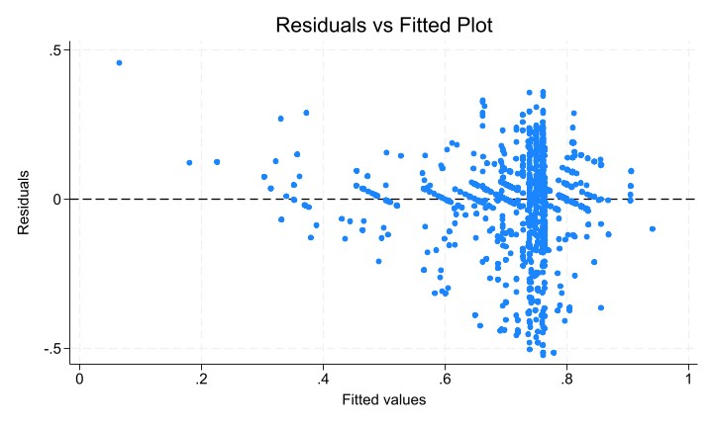
Fig 6: Residual Vs Fitted plot
The residual vs fitted plot shows the residuals plotted against the fitted values for the final regression model, and it provides visual evidence of heteroskedasticity. The residuals are centered around zero, however their spread increases significantly as fitted values approach 0.75 and above. In addition, there is also a single observation on the left of fitted values, representing a team that performed better than the model predicted.
This increasing spread of values in plot indicates the presence of heteroskedasticity. As such, robust standard errors were used in the final regression model to ensure reliable statistical inference in the project.
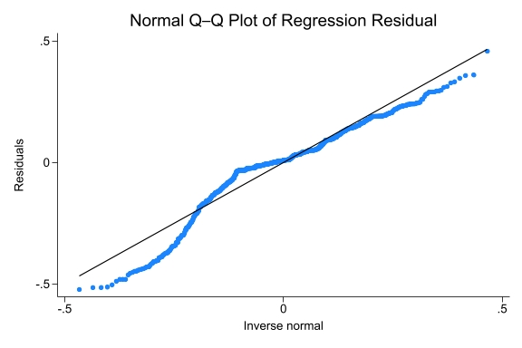
Fig 7: Normal Q-Q plot of regression residuals
Figure 7 shows the normal Q–Q plot of the regression residuals. Most of the points lies close to the straight line, indicating that the residuals are normally distributed. There are some noticeable deviations at the lower and upper tails, indicating some shifts from normality. Overall, the plot indicates that the regression errors are reasonably close to a normal distribution.

Conclusion
This project analyzes garment worker productivity using team-level data from the Bangladesh garment industry, using Ordinary Least Squares (OLS) regression across four model specifications. The results show that targeted productivity is one of the strongest predictors of actual productivity. From this, we can conclude, management should set high but realistic production targets to improve performance. Standard minute value(smv) consistently reduces productivity, while idle men and number of style changes also have negative effects on actual productivity. Productivity in Week 5 is approximately 9.4 percentage points higher than week 1, which may be due to increased deadline pressure at the end of the month. One of the most important findings of this study is the interaction between targeted productivity and departments. The results show that sewing workers respond nearly five times more strongly to management targets than finishing workers, suggesting that department-specific management strategies may be more effective than a uniform approach.

Future Improvements
The study in future can be improved by including worker level data instead of team averages to analyze individual productivity. Likewise, additional explanatory variables like employee experience and training programs could improve the prediction for actual productivity. We can also extend the analysis by applying panel data to better control for unobserved team department specific characteristics over time, since the same team has been observed over three months. Similarly, we can also provide a non-linear relationship or interaction term between variables to further analyze how productivity responds to different management strategies across departments.

Business Implications
The research analysis indicates that targeted productivity is the major determinant for the actual productivity which suggests management should set ambitious yet realistic productivity targets for the employees. Also, since employees in the sewing department respond well to the management targets, there should be different targeting strategies for the sewing and finishing department. Management should also focus on reducing work disruptions like high standard minute values, no of style change and Idle men. Each additional men decreases the actual productivity by 0.73 percentage points, as such there should be investment in machines and supply of material to improve the productivity. Also, number of style changes in the product should be minimized since each additional change in style decreases productivity by 0.0197 units.

